Save the Date!
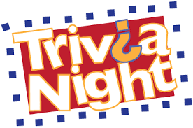
Saturday, January 27th
7:00 pm at the High Lane Club

A fun, adults-only event organized by the parents of the 6th grade class.
Details coming soon.

